NSS REPORT 2022-23
NSS activities of the college during the academic year 2022-23 were conducted off-line after the pandemic. There was an active participation of the students when the NSS activities got resumed to off-line mode. NSS activities for the year started on 5/06/2022 with the observation of World Environment Day. NSS volunteers cleaned the campus and planted trees in the garden. In connection with the programme, a message on the importance of nature was delivered by the NSS Programme Officer. NSS day was also observed by cleaning the campus.
On 25/6/2022 the NSS unit along with Centre for Neuroscience, Cochin University of Science & Technology conducted ‘Dementia Awareness’ programme at Koothattukulam Town. Pamphlets to create awareness about dementia were distributed among the public. NSS volunteers of the college actively participated in this awareness drive.

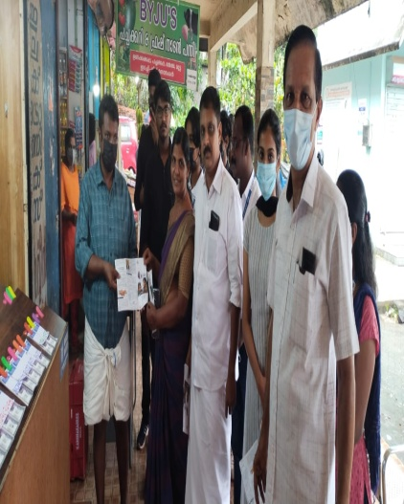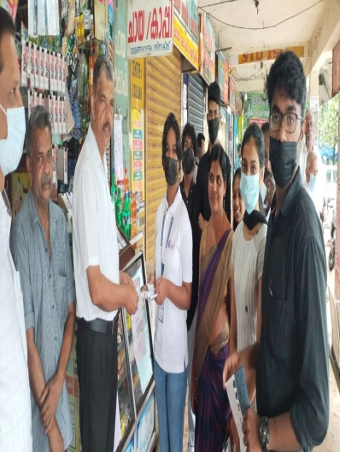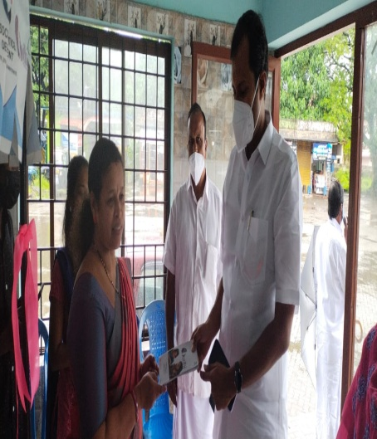

As per the direction from the Directorate of Collegiate Education a Freedom Wall was designed by the NSS Unit to celebrate India’s 75th Independence Day. NSS volunteers painted pictures commemorating Indian freedom struggle under the supervision of famous artist Sri.Vasudevan, former NSS programme officer Ms. Sajitha G and NSS Programme officers Sri. Nirmal Sabu and Dr Jija J. The Freedom Wall was inaugurated on 15/8/ 2022 by the Principal Dr. Roy Scaria.

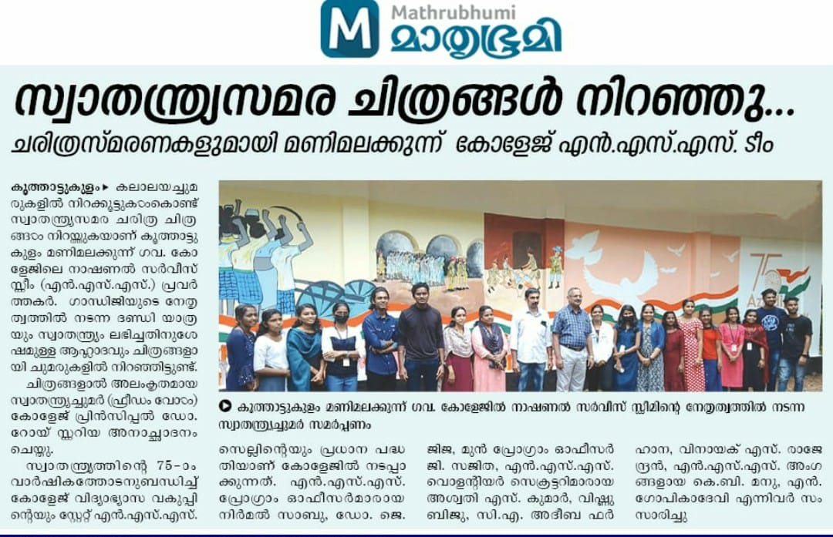
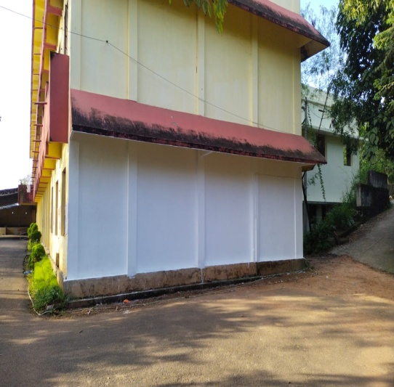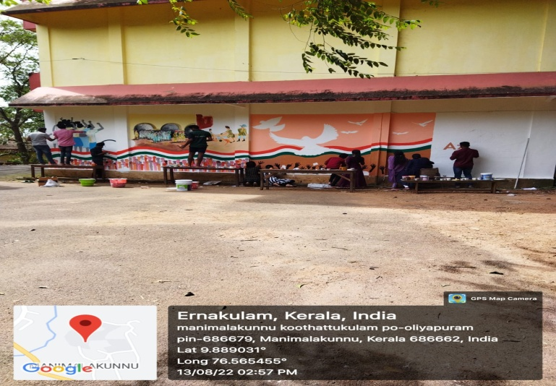
On 5/9/2022 the unit celebrated Teacher’s Day by distributing sweets among teachers and wishing them.

On 2/10/2022 the unit actively took part in ensuring the participation of students in the anti -drug campaign led by the Chief Minister of Kerala Sri. Pinaray Vijayan which was telecasted through the Victor’s channel. Campus cleaning was also done on Gandhi Jayanthi.
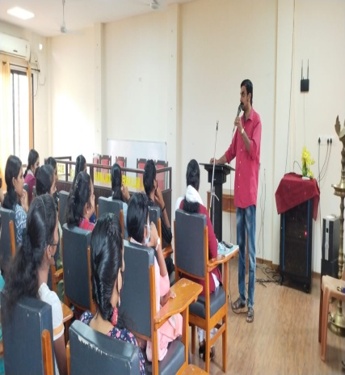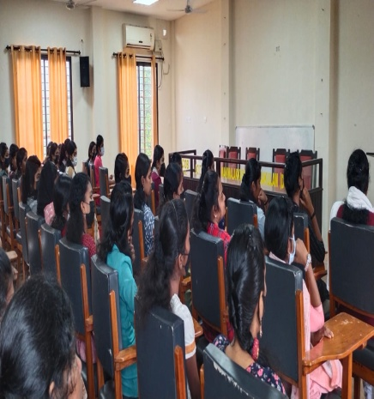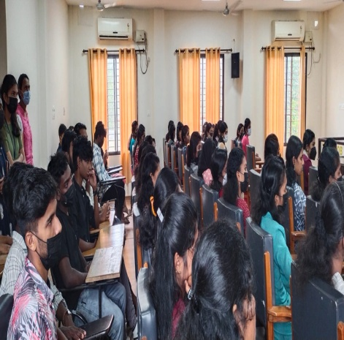

The unit along with Oliyyapuram Anganavadi organized a class on the topic ‘Adolesence issue and Drug abuse’ on 7/10/2022. The class was led by MS. Divya P Mohan and Ms. Arya Devi, community Councillor, Kudumbasree in which II ^{nd} year NSS volunteers participated.

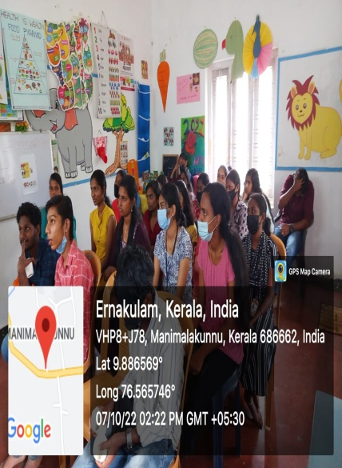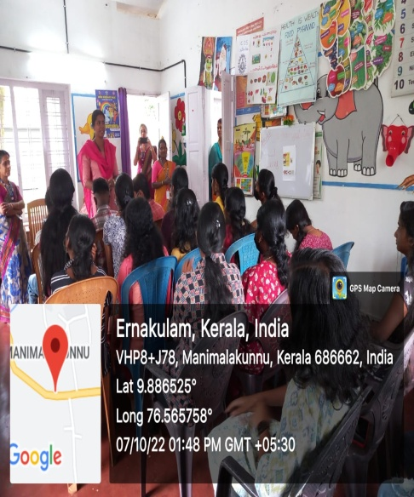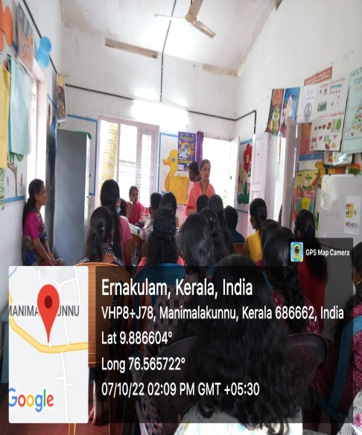

On 27/10/2022, College NSS unit along with DSS MG University Kottayam jointly organized a one day workshop on the topic ‘ I am changing and through me the Society’. The programme was inaugurated by Sri M M George Panchayath Vice President ,Thirumarady,. Principal of the College Dr Roy Scaria, anti- Narcotic Cell convenor Dr. Laigi Joseph were present in the programme. The programme also included a class by Dr. Motty Sacharia Rtd Associate Professor, St. Stephens College, Uzhavoor and Faculty of Humanistic Psychology, Germany.
On 28/10/2022 NSS unit and Anti- Narcotic cell of the college jointly conducted Ati- drug awareness campaign and also conducted department vise debate to create awareness about the danger of drug usage among the youth.

On 1/11/2022 as part of the programme ‘Drug free Kerala’ the NSS volunteers, teachers and students formed human chain and took an oath against the use of drugs.

On Childrens Day (14/11/2022) the NSS unit visited the anganavadi, distributed sweets among the children and conducted various cultural programmes which the children there really enjoyed.
.
An orientation class was organized on 2/12/2022 for first year NSS volunteers. The sessions were handled by Dr. Ajish K.R, Assistant Professor of Chemistry, CMS College Kottayam and Sri. Jobin George Assistant Professor of Commerce, BPS College.

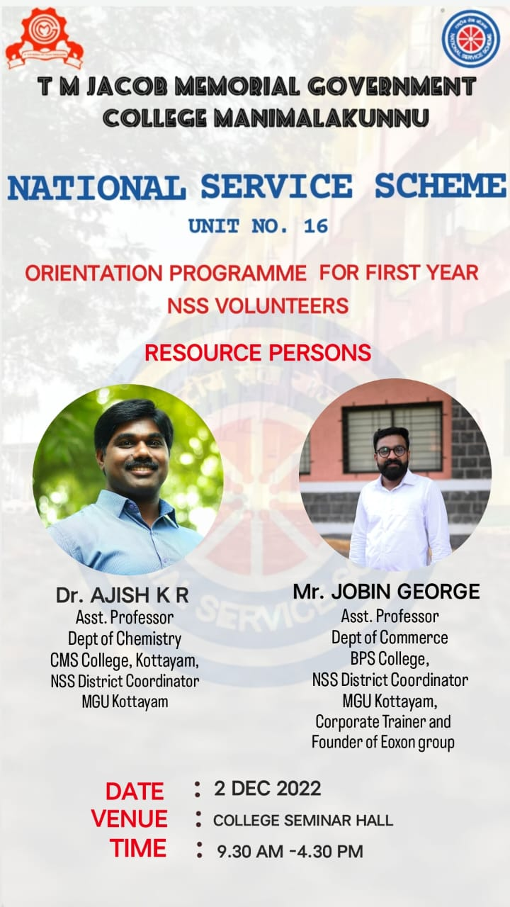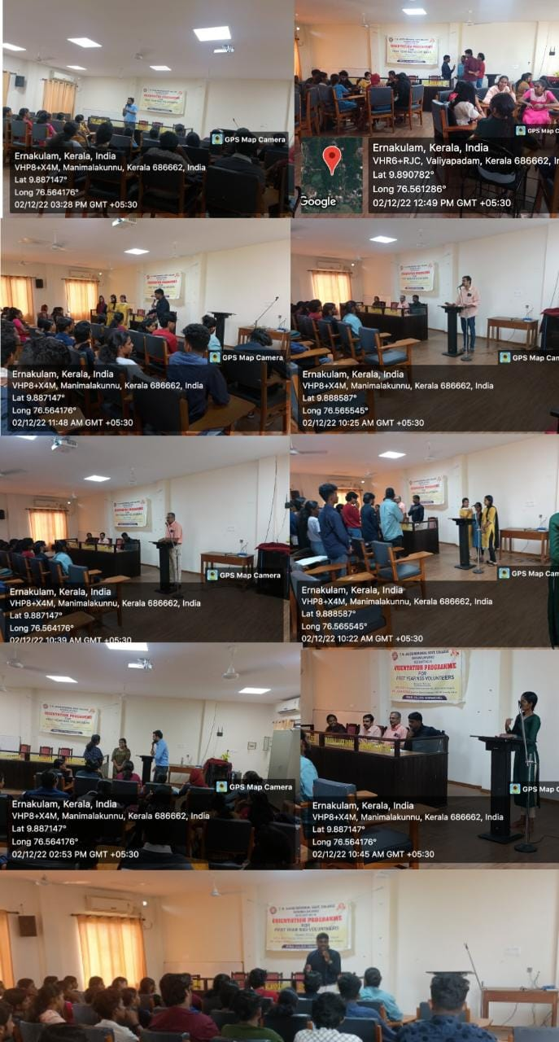

Seven Day Camp
The NSS unit successfully organized a Seven Day Camp at GHSS Athanikal School from 26.12.2022 to 1.01.2023. The camp was inaugurated by Smt. Rama Muralidharaka imal, president of Thirumarady Grama Panchayath. The college principal Dr. Roy Scaria presided over the function in which Athira Sumesh, Ward Member, Sri Reji V.A P.T.A Vice President, NSS Programme Officers Sri. Nirmal Sabu and Dr Jija J addressed the volunteers. Various classes were organized for the volunteers in the following days. The Ice braking session in the first day led by Dr. Aju T.G, Assistant Professor of Physical Education, Maharajas College, made the students to overcome their inhibitions. The following days were engaged by Sri. Roby K.S (Civil Excise Officer), Sri James Mathew( Idukki District Coordinator, NSS), Sri Bichu S. Nair( Assistant Professor of Commerce and management, Mahadeva College Vaikom), Smt. Asha Maria Paul( Psychologist & Social Worker, General Hospital Pala), Sri P.V. Sunil Kumar (Assistant Professor of Malayalam, T.M.J.M Govt. College, Manimalakunnu), and Sri. Chandralal V.S (Assistant professor, Rajagiri College of Management and Applied Science, Kakkanad) took classes on various contemporary relevant topics.
One of the major objectives of the camp were the renovation of the HSS-CC road and Athanikal- Kuttumpuram road and cleaning the athanickal school premisesa. These were completed successfully. As a part of Anti drug campaign, the volunteers conducted anti drug awareness rally and pamphlets to create awareness against drug use among the public.
On 1/01/2023, the concluding day of the programme, a meeting was conducted which was inaugurated by Smt. Athira Sumesh, ward member, Thirumarady and presided over by the Principal Dr. Roy Scaria. The volunteers who performed well in the camp were felicitated in the meeting.

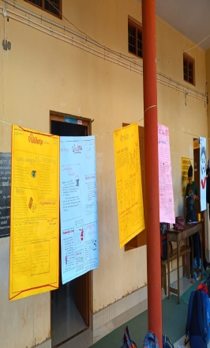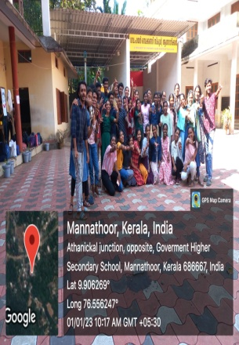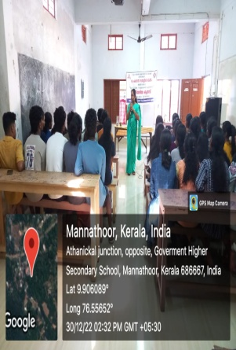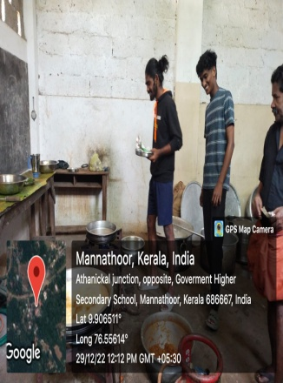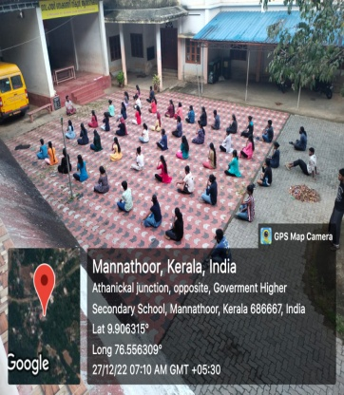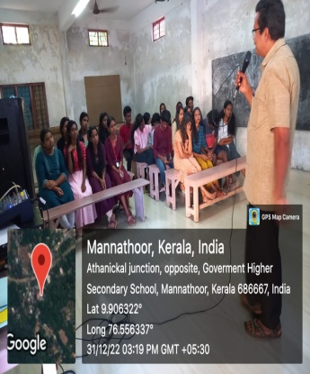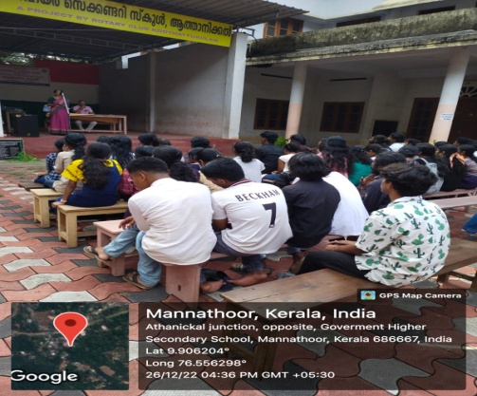

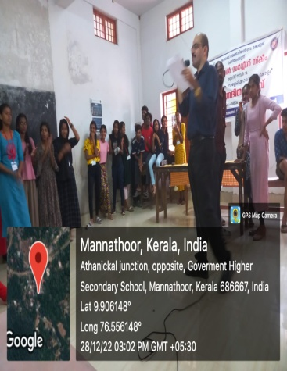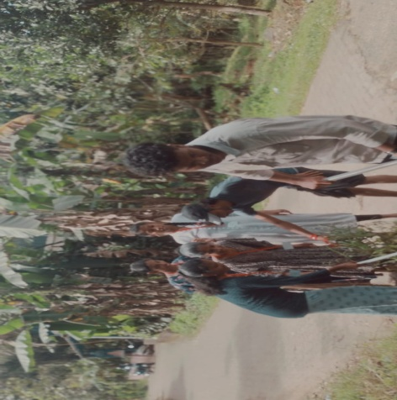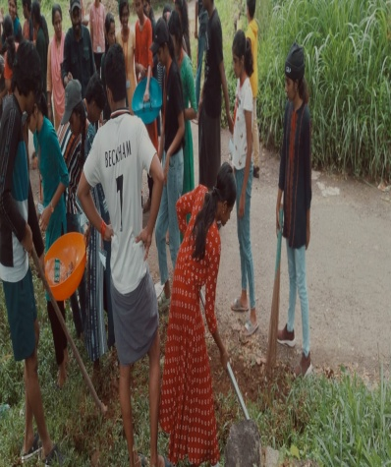
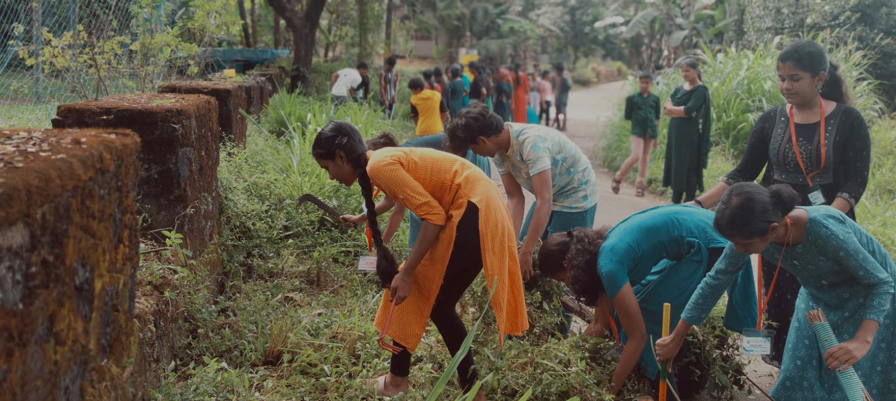

On 8/3/2023 as part of International Women’s Day NSS unit and the Women’s Cell of the college jointly organized a seminar by Dr. Harish Babu (CMO,GHO, Thrikkakkara) on the topic ‘Substance and Behavioural Addiction in Adolescence and Young adults’.
On 23/3/2023 the unit made facilities for birds to quench their thirst in the harsh summer weather. Pots of water were placed at different places in the campus were birds frequently visit and the pots were filled daily by the volunteers.

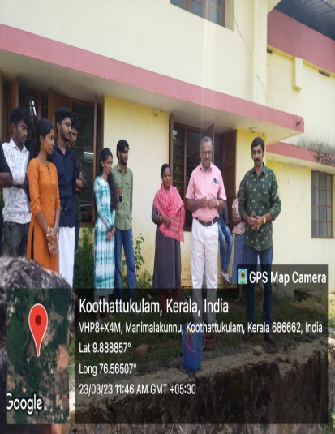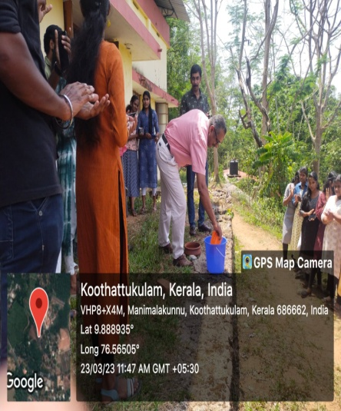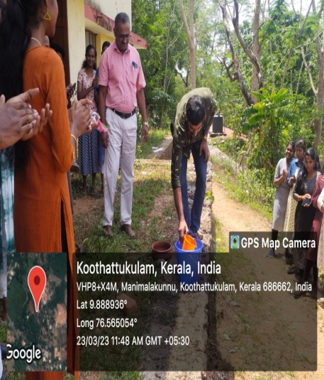

On 24/3/2023 NSS unit and Women’s cell jointly organized a free medical camp in the college. In the camp Dr. Indu, Thaluk Govt. Homeo Hospital and Convener of Sithalayam provided medical service to students, teachers and non teaching staff of the college.

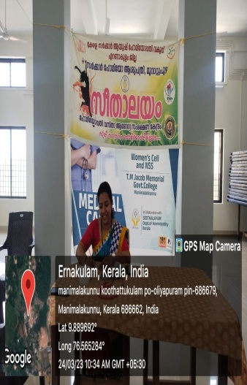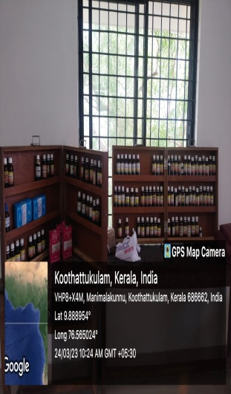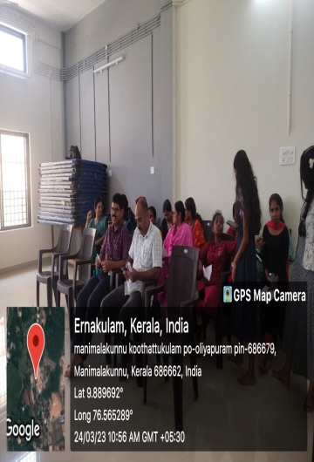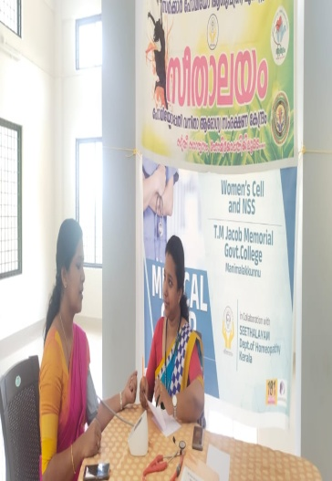
.
The unit made preparations for the Republic Day by cleaning the campus. On 26/1/2023, the unit celebrated the Republic Day by conducting poster designing competition in which students actively participated. Prizes were also distributed to the winners.
The NSS unit of the college is happy and proud that it was able to inculcate qualities like cooperation, responsibility towards nature and society, and service mentality among the students through the different activities it under took. In the coming years the unit hopes to organize more programmes which will be beneficial to both students and the society.

