**Women’s Cell**

**T.M. Jacob Memorial Govt. College, Manimalakunnu**

**Report 2021-22**

As per the guidelines of KSWDC the college constituted a Women’s cell to organise programmes for the Academic Year 2021-22. Ms. Kochurani Joseph, Assistant Professor of English took charge as Women Cell Teacher in Charge.

Ms Ans M George and Ms.Anasooya of III year were selected as student representatives for the training wing.For the conduct of cultural programmes the student representatives Malavika Sukumaran and Nandana Pradeep were selected. Aswathy S. Kumar and Chandana Saranky of I year were elected as student representatives of community Intervention Wing.

Chinju Baiju of II Bcom, Jisna Varghese of I Engilsh, Saranya Sajeev of I Economics, Linet Maria of II English, Gopika devi of II Malayalam volunteered to be 181 WHL representatives

The activities of the Women Cell the Year was officially inaugurated by Adv. Jyothi lekshmi BA LLB by delivering a Legal Awareness Programme “Empowering to Resist” on the online Platform on 13th October 2021. Dr Mercy Joseph Principal presided over the function. Women’s Cell coordinator Ms. Kochurani Joseph welcomed the gathering and Ms. Ans M. George proposed the vote of thanks. 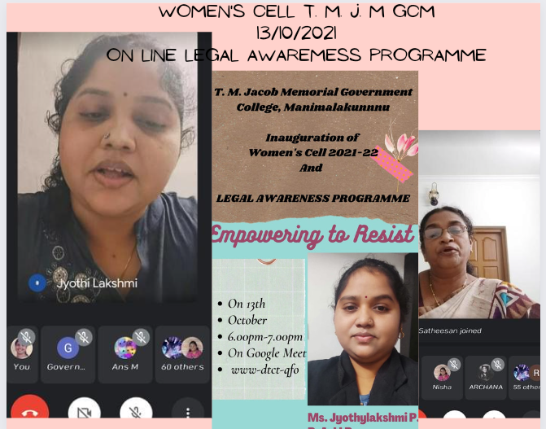

In Connection with International Human Rights Day, we conducted a Programme “Rights Beyond Genders” on 10th December 2021 . Dr Sony T.L Associate Professor of Economics, Sri Achutha Menon Govt. College, Thrissur and Indira Gandhi National NSS Awardee was the speaker for the event convened via Google Meet. 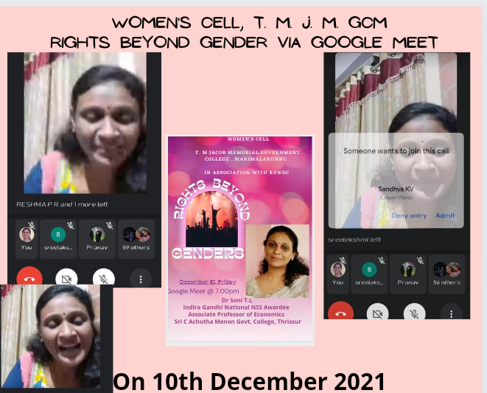

In Association with Kudumbasree Snehitha Gender Help Desk Women’s Cell conducted a programme on Gender Sensitisation and Gender Based Violence on22nd December 2021. Shri. Shine T. Money led the discussion and class on Gender Sensitisation and Smt. Jesmin George talked on Gender Based Violence. 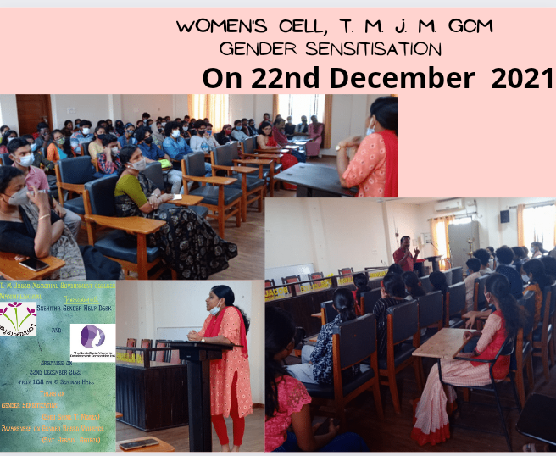

A Debate Competition was organised by the Cultural Wing on the topic “Will Legislation on the Age of Marriage for Girls Empower Women in India?” The team constituted by 1 year English and Physics students won the competition and Rs.1000 as Cash Prize. The Best Debator Award was given to --------and the runners up team got consolation Prizes.

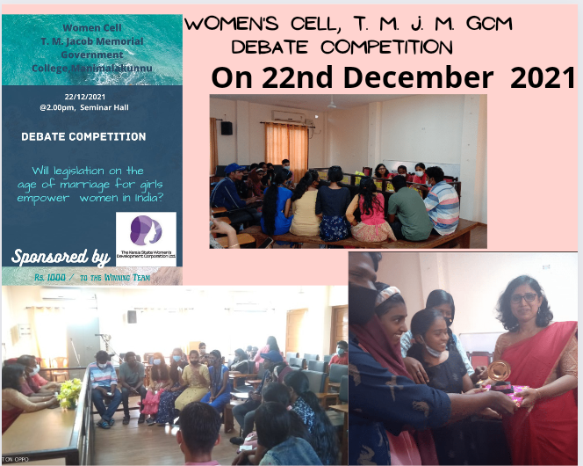

The Cultural wing conducted an Elocution Competition on the topic “Gender Equity: Need and Significance” on 25th February 2022 in collaboration with the Gender Justice Forum. 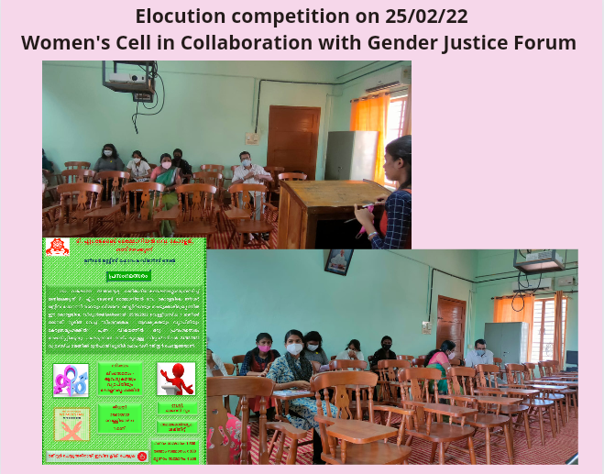

Miss Aswathy S. Kumar won the first prize and Rs. 500 cash prize. Pavithra C. Nair won Second Prize and Rs. 200 cash prize. Sreelekshmi Rajeev got the third position and won Rs.100. Certificates and Cash prize were distributed on 4th March 2022.

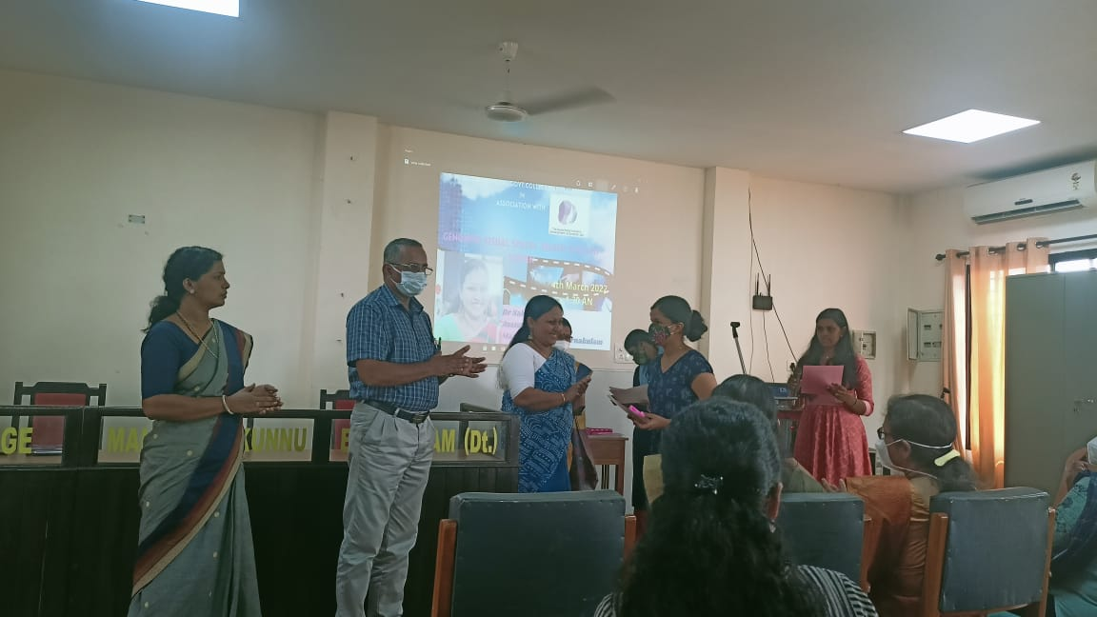

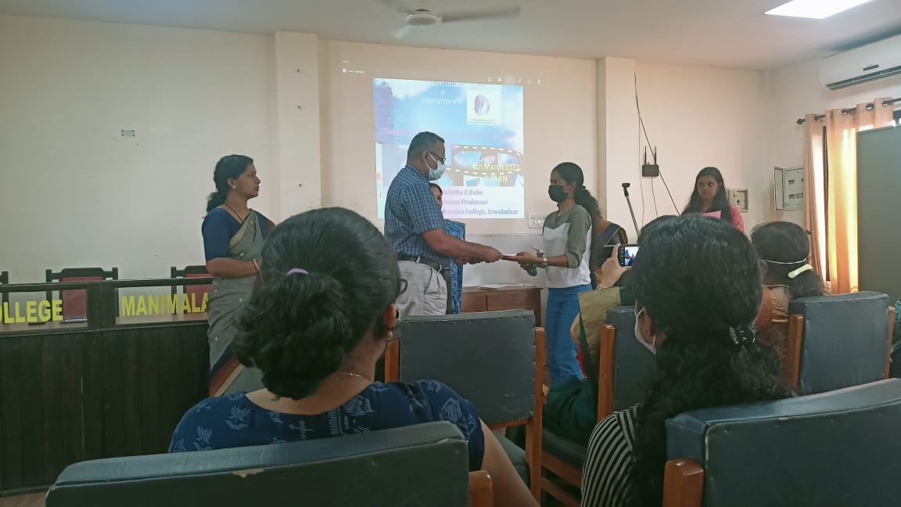

The Cultural wing prepared a manuscript magazine “Akshari” to be released on the wome’s Day. Malavika Sukumaran of II year BA served as Student editor. Anjali Subhash was the student editor in charge of Arts, Dhanasree Pillai of I BA took charge of English writing section while Nandana Pradep of I Bsc coordinated the Malayalam writing section.At the release of the Manuscript magazine “Akshari”, Cash Prize of Rs.500 was rewarded to the Best Contributor Mridhula K.

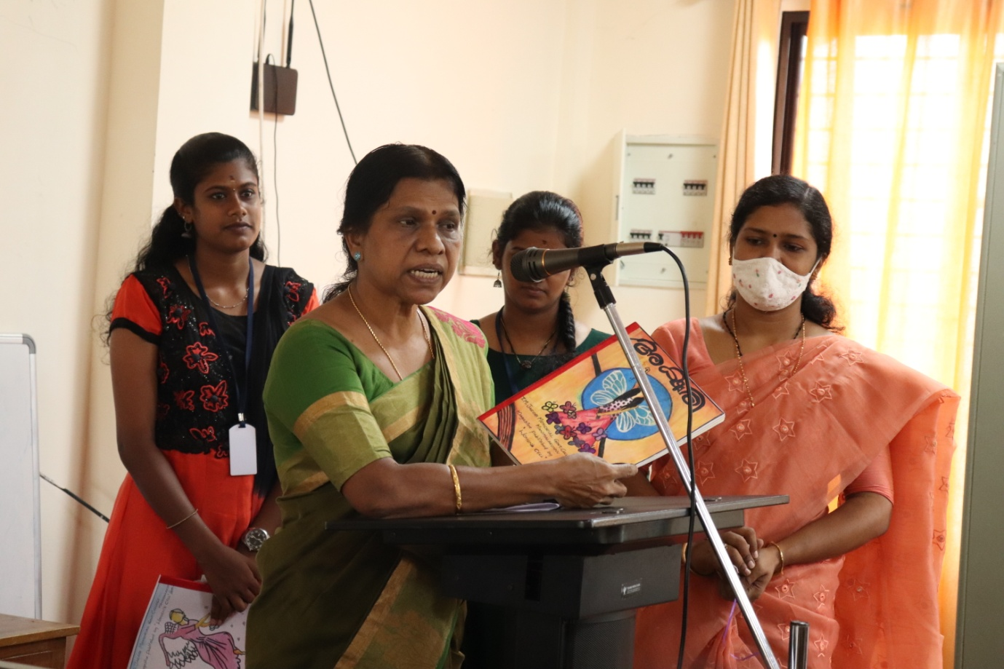

Training Wing conducted a session on “life Style and Women’s Health: An Ayurvedic View” on 2nd March 2022. Dr Sawmya M.Jose, BAMS engaged the session online. She shared practical tips to stay healthy.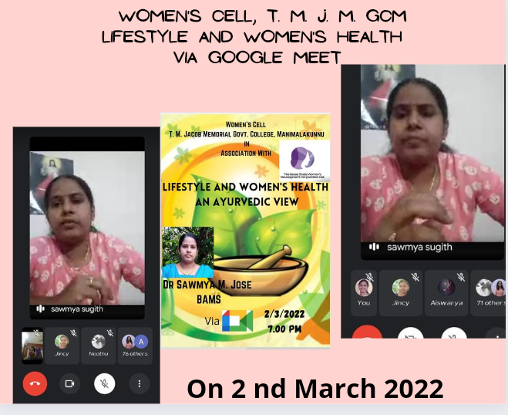

The training wing of Women’s Cell once again Collaborated with the Gender Justice Forum to arrange a session on “Gendered Visual Spaces: Biased Sites on Screen” on 4th March 2022 at the College seminar Hall. Dr Sabitha S Babu, Associate Professor of English, Maharajas College was the speaker. Dr Sheeja T.K, Convener, Gender Justice Forum welcomed the gathering. Dr Roy Scaria, Principal in Charge presided over the function and Women’s Cell coordinator Ms. Kochurani Joseph proposed the vote of thanks.

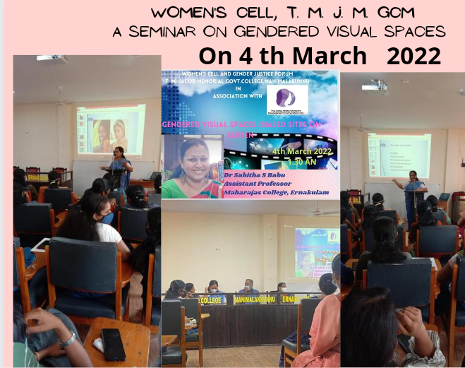

International Women’s day was duly observed on 8th March 2022. Dr Roy Scaria, Principal in Charge presided over the function. Women’s Cell coordinator Ms. Kochurani Joseph welcomed the gathering. Smt. D. Sreedevi, writer and Gender trainer was the Chief Guest of the day. She gave the Women’s Day message to the students. After the celebrations, a class on “Skills for Life and Career” was conducted. Ms Kiran Maria Jose, Assistant Professor, Govt College Kottayam handled the session.

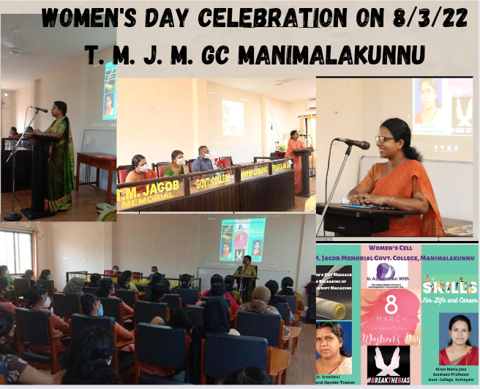

Under the Community Service Wing Hair Donation Campaign was arranged on4th March 2022. It was in association with Ayurveda Medical Association of India, Koothattukulam Area and Amala Institute of Medical Sciences, Thrissur. Office bearers and campaigners talked to the students about the noble cause for Cancer Patients and some students were ready for donation after the Campaign.

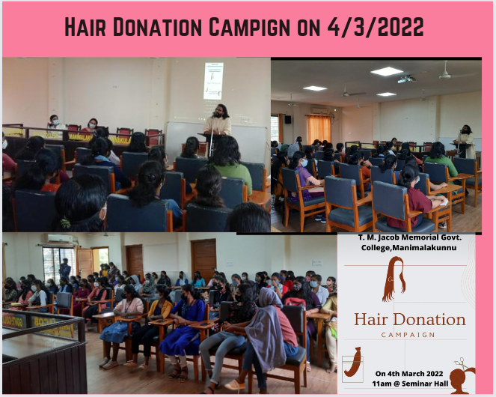

Under the leadership of NSS and Women’s Cell we arranged a venue for hair donation on 8th March 2022. Seven donors from our college and a couple of students from the neighbouring institutions donated their hair.

